Find the slope of the following graphs.

Slopes can be positive or negative. You can find whether it is positive or negative by thinking of the line as a mountain. You are a traveler heading from left to right. Are you traveling up? This is positive. Are you traveling down? This is negative.

Classify each of the following graphs as either positive or negative.
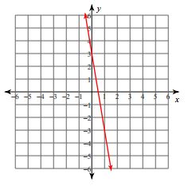
1. 2.

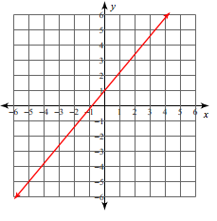
3. 4.

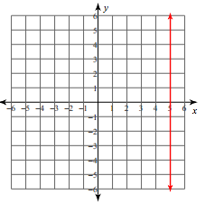
5. 6.

