A. Find the unit rate of each graph.

1.
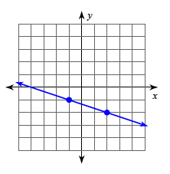

3.

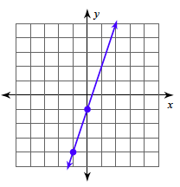

2.

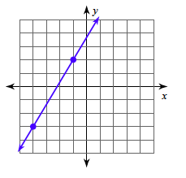

4.

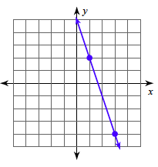

B. Answer the following questions by finding the unit rate:

- You buy 12 DVD’s for $60. How much does one DVD cost?

- Suzi Q bought 24 boxes of Q-tips for a school project. She had to place her boxes in 3 bags. How many boxes were in each bag?

- Mrs. Jacob was making zucchini muffins and making a mess. Her recipe called for 3 cups of flour for 12 muffins. How many cups of flour were in each muffin?

- The eighth grade math teachers ordered two pizzas for lunch. Each pizza had 8 slices. If three teachers wanted to split it evenly, how many slices (or fractions of slices) would each teacher get?

C. Find the unit rate of change (per one x-value) for each table below.

x | 2 | 4 | 6 | 8
y | 6 | 11 | 16 | 21
1.

x | 4 | 9 | 14 | 19
y | 13 | 15 | 17 | 19

2.

x | 1 | 5 | 7 | 11
y | 2 | 8 | 11 | 17
3.

x | 3 | 5 | 13 | 19
y | 7 | 8 | 12 | 15
4.

