End of Year Review | Day 7 | Homework

A. LINES OF BEST FIT

(DOK 1) Describe the following trends.

- 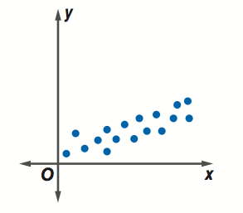
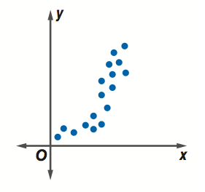

- 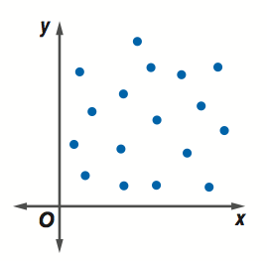
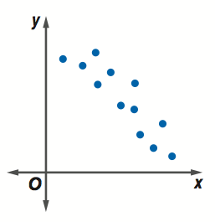

The table shows the life expectancy of people based on the year they were born.
Years Since 1900 | 0 | 10 | 20 | 30 | 40 | 50 | 60 | 70 | 80 | 90 | 100
Life Expectancy | 47.3 | 50.0 | 54.1 | 59.7 | 62.9 | 68.2 | 69.7 | 70.8 | 73.7 | 75.4 | 77.1

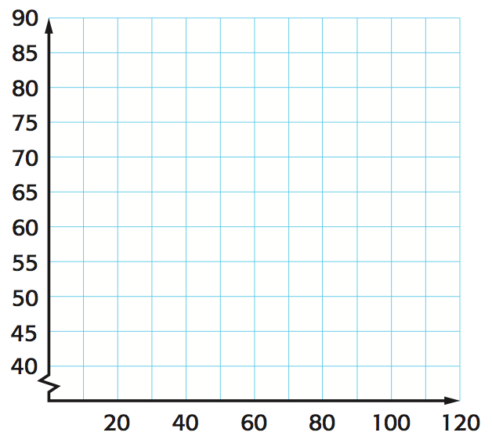
- (DOK 2-3) Construct a scatter plot of the data. What is the life expectancy for a person born in 2020? Why?

B. TWO-WAY TABLES

- (DOK 1) What do you do to determine the relative frequency on a two-way table?

- (DOK 2) There are 150 children at summer camp and 71 signed up for swimming. There were a total of 62 children that signed up for canoeing and 32 of them also signed up for swimming. Construct a two-way table summarizing the data.

 | Canoeing | No Canoeing | Total
Swimming
No Swimming
Total

- (DOK 2) Which of the following interpretations is most correct?
  - Of the students who went to summer camp, more than half chose to swim.
  - There is a strong association between those that go to camp and those that canoe.
  - There is a strong association between those that canoe and also swim.
  - Students who swim are more likely than not to canoe.

Megan surveyed the 8th grade to find which school activities they attended last weekend. The results are shown in the two-way table.

 | Attended the School Play | Did Not Attend the School Play | Total
Attended the Basketball Game | 55 | 63 | 118
Did Not Attend the Game | 88 | 15 | 102
Total | 143 | 78 | 221

- (DOK 3) What has a higher association: not attending the basketball game but attending the play, or not attending the play but attending the basketball game? Why?

