End of Year Review | Day 5 | Homework

A. SOLVING EQUATIONS
(DOK 2) Solve each of the following equations.
- $2x+5=12$

- $\frac{2}{3}x+4=20$

- $3\left(x-1\right)=42$

- $2x=x-4$

- $4\left(x+1\right)=2(x+7)$

B. TYPES OF EQUATIONS

- (DOK 1) What is slope-intercept form? Explain each variable.

- (DOK 1) What is point-slope form? Explain each variable.

- (DOK 1) What is standard form? Explain each variable.

- (DOK 2) What are the x- and y-intercepts of the following functions? Write them as coordinate pairs.
  - $-6x+8y=24$

  - $\frac{3}{4}x-6y=18$

  - $-x-y=12$

- (DOK 2) Write point-slope form for the following lines.
  - Passes through (-5, 6), slope = 3

  - Passes through (0, 1) and (2, 5)

  - Passes through (-5, 9) and (1, 3)

C. SYSTEMS OF EQUATIONS
(DOK 2) Find the solution to the following system of equations by graphing.
- $y=3x+4$ and $y=-x-4$
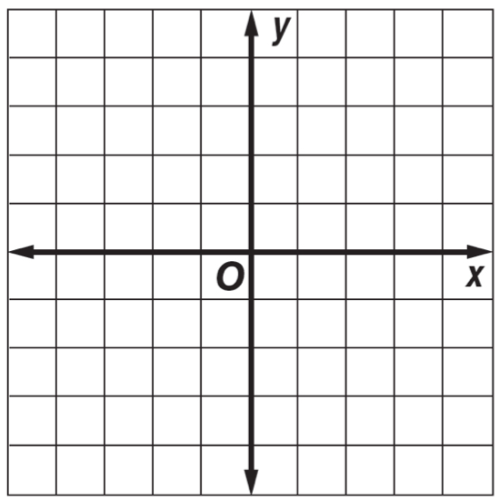
- $y=10+6x$ and $y=6x$

(DOK 2) Find the solution to the following systems of equations by using algebra.
- $y=x+2$ and $y=-3x$

- $y=-x-4$ and $y=x$

- $y=3x+2$ and $-2x+2y=20$

- (DOK 3) Jordan won the ping-pong championship eight more times than Jacob. They have won a combined total of 32 championships. How any games did each boy win?

- (DOK 3) Corey has $5 and $10 bills in his wallet. He has 5 times as many $10 bills as $5 bills. How many of each does he have?

