End of Year Review | Day 4 | Homework

A. FUNCTION NOTATION

- (DOK 1) Find f(-14) if f(x) = 2x – 3.

- (DOK 1) Find f(3) if f(x) = 2x + 4.

- (DOK 1) Find f($\frac{3}{4})$ if $f\left(x\right)= 2x-\frac{1}{4}$.

- (DOK 2) The school math team wants to have each member’s name imprinted on the member’s jacket. The cost for printing, design, and shipping is $135, plus $8.50 for each name. Write a function to represent the cost for x names.

- (DOK 2) What is the cost to have names imprinted on 25 jackets?

- (DOK 2) Alison is a member of a theater club. She pays a monthly fee and her movie tickets are then $5 for an unlimited number of movies for that month. The graph shows the cost for each month. What is the monthly fee?
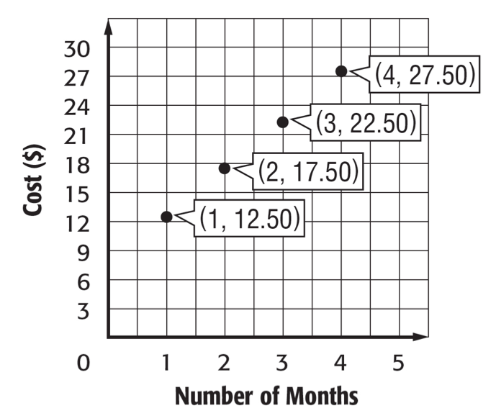
- (DOK 2) Write a function for the relationship above in slope-intercept form.

- (DOK 3) Ed Sheeran is signing autographs. While setting up his stand, he signed 10 autographs. After officially beginning, he signed 20 personalized autographs per hour! Rumor has it that the 100th customer is being flown to London for his concert. At what time will the 100th customer have his CD signed? Explain your thinking.

B. COMPARING FUNCTIONS

- (DOK 1) How do you find a slope on a table? Explain below.

- (DOK 1) How do you find a slope on a graph? Explain below.

- (DOK 1) Where do you find the slope in the equation y=mx + b?

- (DOK 1) How do you find the y-intercept on a table? Explain below.

- (DOK 1) How do you find the y-intercept on a graph? Explain below.

- (DOK 1) Where do you find the y-intercept in the equation y=mx + b?

- (DOK 2) Perfect Picture charges $11 per photo with a $5 prop fee initially. The graph shows the fees for Creative Memories Studio. Which function has a lower constant rate of change?
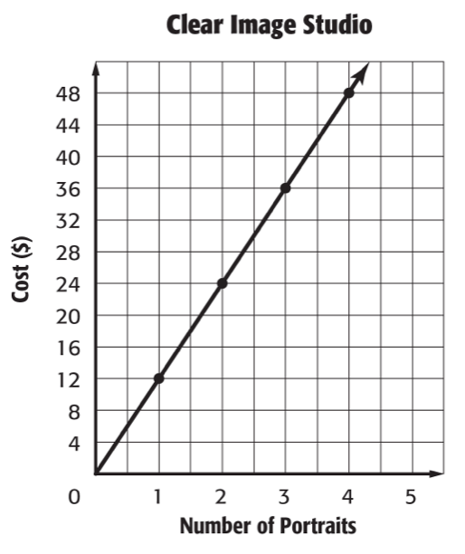

- (DOK 3) The table shows the cost for traveling on a toll road on I-65. The graph shows the cost of traveling on a toll road on I-70. Assuming the distance you travel is the same either way, which road would you rather take? Why?
