End of Year Review | Day 3 | Homework

A. SLOPE AND CONSTANT RATE OF CHANGE

- (DOK 1) What do you do to find the slope on a table? Describe and demonstrate below.
x | 0 | 2 | 4
y | -3 | 1 | 5

- (DOK 1) What does a relationship need to be linear?

- (DOK 2) Below is a graph of a hawk diving toward its prey. Is the following relationship linear? Explain how you know.
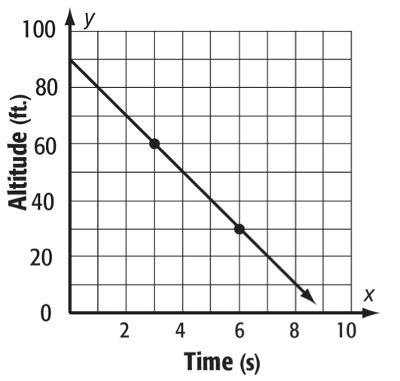
- (DOK 2) Below is a record of the distance Cameron traveled on his bike trip over spring break. Is the relationship linear? Explain why or why not.

Day | 1 | 2 | 3 | 4
Distance (mi) | 21.8 | 43.6 | 68.8 | 90.6

B. SLOPE-INTERCEPT FORM

- (DOK 1) What is the equation for slope-intercept form?

- (DOK 1) What does the letter m represent and how do we find it?

- (DOK 1) What does the letter b represent and how do we find it?

- (DOK 1) State the slope and the y-intercept for the equation y=-4x+2.

(DOK 2) What are the equations for the following graphs?

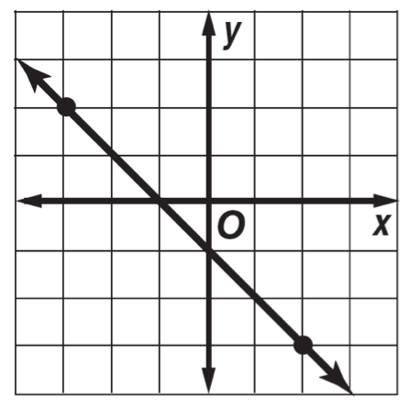

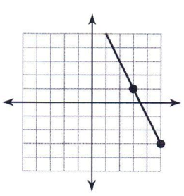

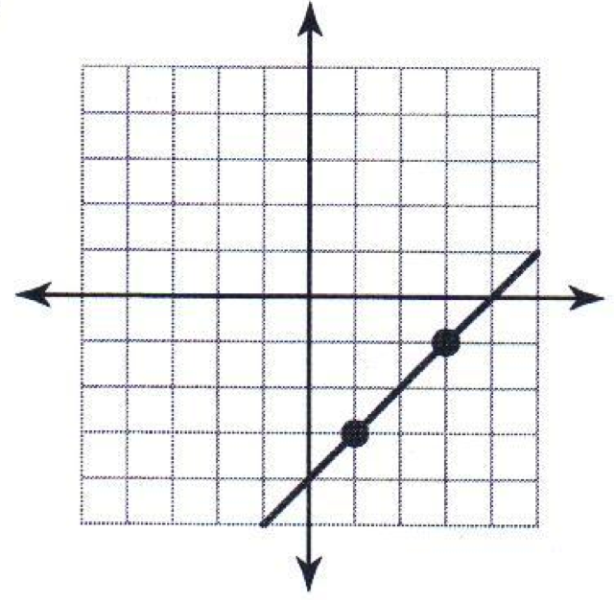

(DOK 2) Graph the following equations:
- $y=-3x+3$
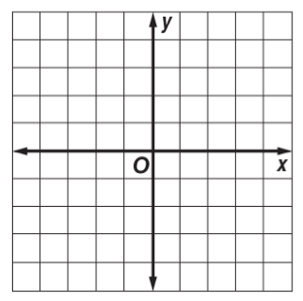
- $$y=\frac{1}{2}x-4$$
- $$y=-\frac{2}{3}x+5$$

The entrance fee to the national park Mrs. Jacob visited over Spring Break is $10. A campsite fee is $15 per night.

- (DOK 1) Write an equation that can represent the cost, y, for any number of nights, x.
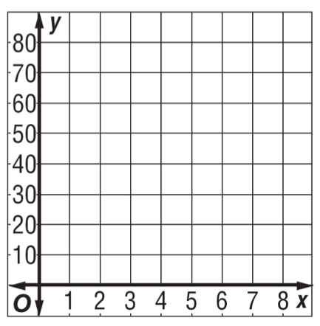

- (DOK 2) Graph the equation you created on the graph provided.
- (DOK 2) What is the cost if Mrs. Jacob stayed for 4 nights?

The table below shows the fabric needed to complete the costumes for the spring musical. The drama department has to decide whether to make the costumes or purchase them already made. To buy them from an online retailer, they would pay a $25 expedited shipping fee plus $8 per costume purchased.

Number of Costumes | 2 | 4 | 6 | 8
Fabric Cost ($) | 21 | 42 | 63 | 84

- (DOK 3) Which method is best, ordering the costumes or making them? Explain your reasoning.

