End of Year Review | Day 2 | Homework

A. CONGRUENCE AND SIMILARITY

- (DOK 1) What transformations must occur to preserve congruence?

- (DOK 1) What transformations must occur to preserve similarity?

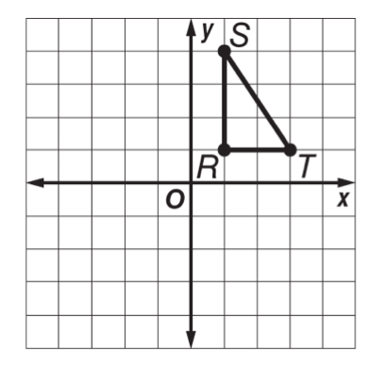
- (DOK 2) Triangle RST has vertices R(1, 1), S(1, 4), and T(3, 1). Graph the figure and its rotated image after a clockwise rotation of 180° about the origin. Then give the coordinates of the vertices for triangle RʹSʹTʹ.

- (DOK 2) Triangle BDF has vertices B(4, 3), D(6, 3), and F(6, 1). What are the coordinates of the image of point F after a translation 2 units to the left and 4 units down?

- (DOK 2) Quadrilateral MNOP has vertices M(–2, 4), N(–2, 1), O(3, 1), and P(3, 4). What are the coordinates of the image of point P after a reflection across the x-axis?

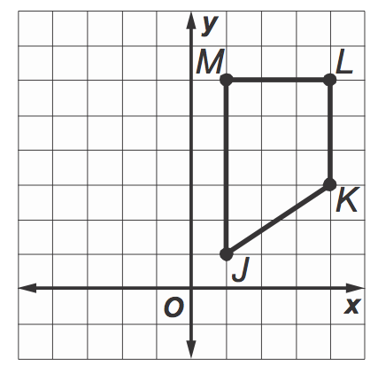
- (DOK 2) A quadrilateral has vertices J(1, 1), K(4, 3), L(4, 6) and M(1, 6). What are the coordinates of the image after a 90$°$ counterclockwise rotation around the origin? Graph and label the coordinates of the image created by the rotation.

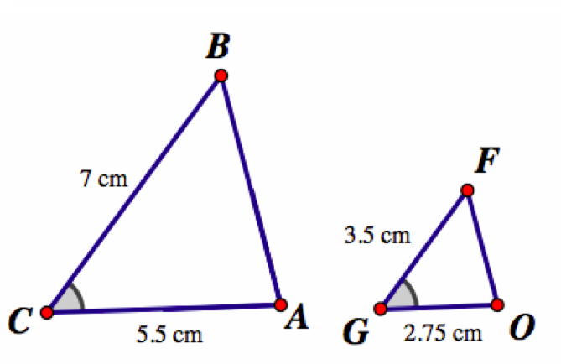
- (DOK 3) Classify the following figures as either similar or congruent. Justify your reasoning by explaining why you know you are correct.

B. VOLUME

- (DOK 1) Write the volume formulas for the following shapes:
  - Cylinder:

  - Cone:

  - Sphere:

- (DOK 2) Find the volume of the cylinder. Round to the nearest tenth.
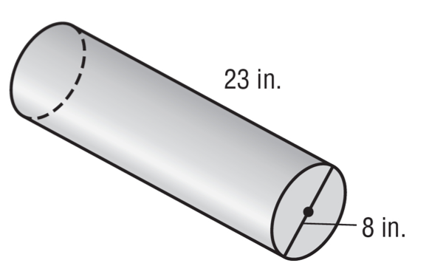
- (DOK 2) Find the volume of the cone. Round to the nearest tenth.
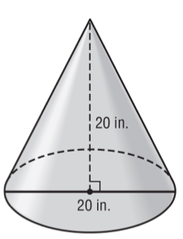
- (DOK 2) Find the volume of the hemisphere. Round to the nearest tenth.
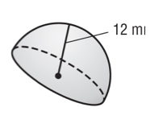
- (DOK 3) Two fuel tanks with the dimensions shown have the same volume. What is the value of h?
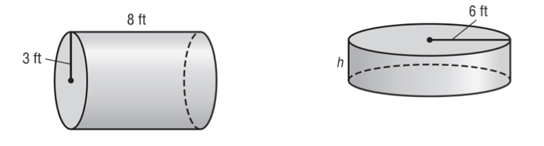

- (DOK 3) Find the area of the base if a cone has a volume of 36 cubic inches and a height of 9 inches.

