End of Year Review | Day 1 | Homework

A. ANGLES OF TRIANGLES

- (DOK 1) What is the sum of all the angles in a triangle?

- (DOK 2) – Find the value of x.

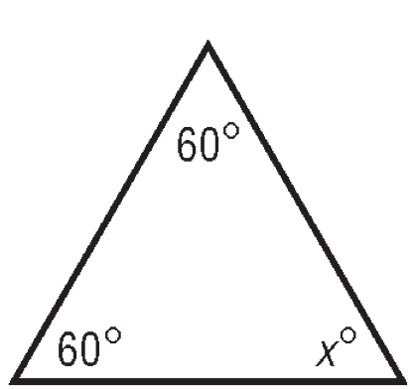

- (DOK 2) In XYZ, m∠Z = 113° and m∠X = 28°. What is m∠Y?

- (DOK 3) Find the value of x.

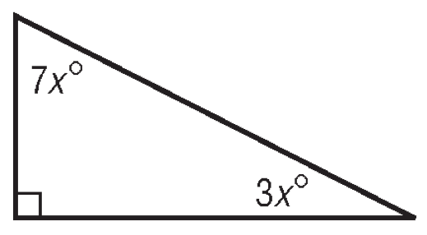

B. ANGLES RELATIONSHIPS

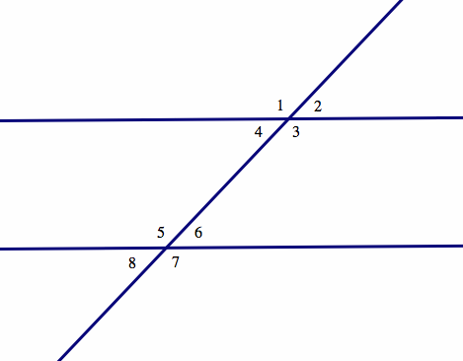
- (DOK 1) Using the picture at right, list all congruent angles under the specified categories.

Corresponding Angles:

Vertical Angles:

Alternate Interior Angles:

Alternate Exterior Angles:

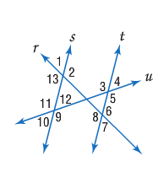
- (DOK 2) Refer to the figure at the right. Line s is parallel to line t, m $∠2$ is 110$°$ and m $∠11$ is 137$°$. Find each given angle measure. Justify your answer

m $∠7$ __________________________________

m $∠8$ __________________________________

m $∠3$ __________________________________

- (DOK 3) Solve for x in parallelogram GEDF

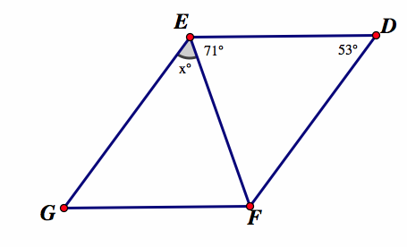

- (DOK 3) Two congruent tiles have been laid along a straight path.

Explain why w + x + y = x + z.

______________________________________________________________________

______________________________________________________________________

C. PYTHAGOREAN THEOREM

- (DOK 1) What is the Pythagorean Theorem? What do the variable represent? And when would you use it?

______________________________________________________________________

______________________________________________________________________

- (DOK 2) How high is the end of the ladder against the building.

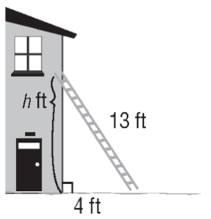

- (DOK 2) Determine whether a triangle with sides 18 ft, 23 ft, and 29 ft is a right triangle. Explain your answer.

- (DOK 3) Remember the farmer and his neighbors? If you didn’t know the Pythagorean theorem, how would you know the lightest field is equal to the area of the other, darker, fields?

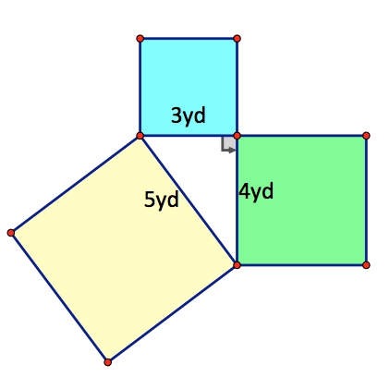

______________________________________________________________________

______________________________________________________________________

- (DOK 3) Suppose another farmer and his neighbors are trying to figure out if the area of the bigger field is equal to the area of the other two fields combined. If you only knew the side lengths of the all the fields could you determine if the watering hole (the triangle in the middle) is a right triangle? Explain your answer.

______________________________________________________________________

______________________________________________________________________

______________________________________________________________________

______________________________________________________________________

